THE AMERICAS

THE IMPORTANCE OF THE AMERICAS

THE ORGANIZATION OF AMERICAN STATES

THE PAN AMERICAN ASSOCIATION OF KANSAS CITY

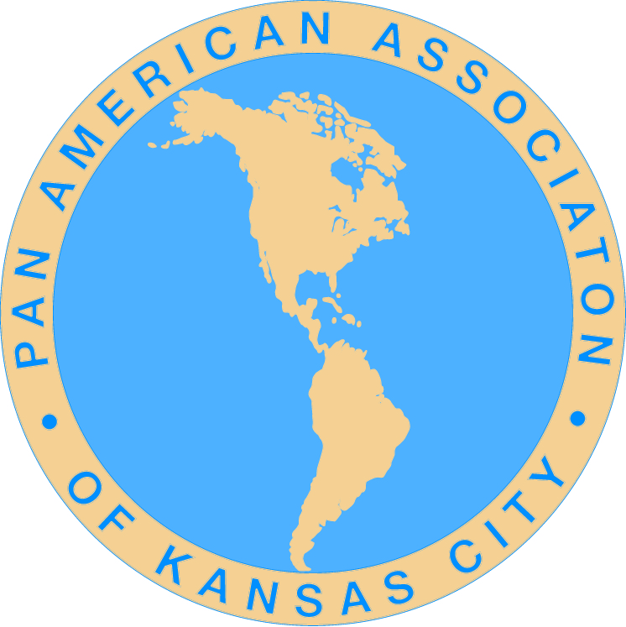

Please share a copy of this document with colleagues, business associates, friends and family, especially any family members who are students

Courtesy of the Pan American Association of Kansas City, Inc.

2015

THE AMERICAS

The Americas are in the Western Hemisphere and include Canada, the United States, Mexico, Central America, South America and the Caribbean countries. A color map of the Americas, in two sizes, can be downloaded from the Pan American Association of Kansas City website, www.panamkc.org, under the Resource Tab.
WHY ARE THE “AMERICAS” IMPORTANT?
The Americas, as a region is, directly or indirectly, important to each of us and to the world at large:
- The population of the Americas is estimated to be over one billion people which equals approximately 14-15% % of the estimated population of the world.
- Trade between the Americas and other nations of the world amounts to trillions of dollars each year, which contributes to jobs, prosperity, and economic development in most all countries of the Americas as well as in other countries of the world.
- Natural resources of countries of the Americas are important to the countries of the Americas and the world economy. Resources such as oil, gas, minerals, precious and other metals.
- A substantial percentage of the world’s wheat and corn is grown in the Americas.
- 57% of the world’s rainforests are in the Americas. At vast percentage of the developed world’s diet originated in the tropical rainforests; fruits such as avocados, coconuts, figs, oranges, lemons, grapefruit, bananas, guavas, pineapples, mangoes, and tomatoes; vegetables including corn, potatoes, rice, winter squash and yams; spices like black pepper, cayenne, chocolate, cinnamon, cloves, ginger, sugarcane, turmeric, coffee and vanilla and nuts including Brazil nuts and cashews.
- The Amazon Rainforest has been described as the “Lungs of our Planet” because it provides the world the essential environmental service of continuously recycling carbon dioxide in oxygen. More than 20 percent of the world oxygen is produced in the Amazon Rainforest.
- The Amazon Rainforest covers over a billion acres, encompassing areas in Brazil, Venezuela, Colombia and the Eastern Andean region of Ecuador and Peru. If Amazonia were a country, it would be the ninth largest in the world.
- More than one half of the world’s estimated 10 million species of plants, animals and insects live in the tropical rainforests. One-fifth of the world’s fresh water is in the Amazon Basin.
- The Panama Canal is critical to world commerce. 12-15,000 ships transit the canal annually, carrying a record tonnage of 337.7 million tons. The Canal has been designated one of the “modern wonders of the world.” A third set of locks, under construction, will double the capacity of the Canal.
THE SIGNIFICANCE AND IMPORTANCE OF THE COUNTRIES OF THE AMERICAS TO EACH OTHER
Geographical significance:
- The countries of the Americas share the same hemisphere (Western Hemisphere).

1

Historical and cultural significance and similarities:
- Most countries share a common history of exploration, discovery, conquest and settlement by European nations
- Most countries experienced slavery, extinction or marginalization of indigenous people.
- Most countries have a common background of gaining independence through revolution.1
- Most countries share a post revolution emphasis on freedom, liberty, and individual initiative, agricultural then industrial development.
- Many hemisphere countries patterned their governmental systems and constitution after that of the U.S. constitution.
- Most all countries of the Americas believe in representative democracy.
- Populations of many hemisphere countries grew through immigration, inter-marriage, and some assimilation of natives.
- There is some commonality of religions, legal, and educational systems.
- There is widespread adoption of regional foods, movies, music, and TV shows among the countries.
- Large numbers of students from the countries of the Americas study in other countries of the Americas
- Local: Missouri and Kansas: Kansas City and regional communities have populations that either have immigrated or traced their heritage to countries of the Americas. Regional Colleges and Universities have many students enrolled from countries the Americas. Regional nonprofits and religious institutions have ties to countries of the Americas and engage in cultural and other exchanges as well as conducting humanitarian projects.
Peace and Security
- Most nations signed the Treaty of Rio in 1946, which calls for reciprocal support in case of outside attack
- Most nations cooperate in fighting drugs, multinational crime, and trafficking in humans
- There is cooperation among most law enforcement agencies
Economic Development and Trade Facts
- Most all countries of the Americas engage in trade or tourism with the U. S. and with other countries of the Americas. Annual trade between countries of the Americas is close to $2 trillion annually.
THE ORGANIZATION OF AMERICAN STATES
The Organization of American States (OAS) brings together the countries of the Western Hemisphere to strengthen cooperation and advance common interest. It is the region’s premier forum for multilateral dialogue and concerted action. The OAS is like the “UN” of the Americas and it is the oldest regional organization of its kind in the world. It does not however field peace keeping forces in the hemisphere.
The notion of an international union in the New World was first put forward by Simón Bolívar, President of Gran Colombia, who, at the 1826 Congress of Panama (still being part of Colombia), proposed creating a league of American republics, with a common military, a mutual defense
2
pact ,and a supranational parliamentary assembly. This meeting was attended by representatives of Gran Colombia (comprising the modern-day nations of Colombia, Ecuador, Panama, Venezuela, Peru, and Bolivia), The United Provinces of Central America, and Mexico but the grandly titled "Treaty of Union, League, and Perpetual Confederation" was ultimately ratified only by Gran Colombia.
The pursuit of regional solidarity and cooperation again came to the forefront in 1889–1890, at the First International Conference of American States. Gathered together in Washington, D.C., 18 nations resolved to found the International Union of American Republics, served by a permanent secretariat called the Commercial Bureau of the American Republics (renamed the "International Commercial Bureau" at the Second International Conference in 1901–1902). These two bodies, in existence as of 14 April 1890, represent the point of inception to which today's OAS traces its origin. At the Fourth International Conference of American States (Buenos Aires, 1910), the name of the organization was changed to the "Union of American Republics" and the Bureau became the "Pan American Union". The Pan American Union Building was constructed in 1910, on Constitution Avenue, Northwest, Washington, D.C.
In the mid-1930s, U.S. President Franklin Delano Roosevelt organized an inter-American conference in Buenos Aires. One of the items at the conference was a "League of Nations of the Americas", an idea proposed by Colombia, Guatemala, and the Dominican Republic. At the subsequent Inter-American Conference for the Maintenance of Peace, 21 nations pledged to remain neutral in the event of a conflict between any two members. The experience of World War II convinced hemispheric governments that unilateral action could not ensure the territorial integrity of the American nations in the event of external aggression. To meet the challenges of global conflict in the postwar world and to contain conflicts within the hemisphere, they adopted a system of collective security, the Inter-American Treaty of Reciprocal Assistance (Rio Treaty) signed in 1947 in Rio de Janeiro.
The Ninth International Conference of American States was held in Bogotá between March and May 1948 and led by United States Secretary of State George Marshall, a meeting which led to a pledge by members to fight communism in the western hemisphere. This was the event that saw the birth of the OAS as it stands today, with the signature by 21 American countries of the Charter of American States on 30 April 1948 (in effect since December 1951). The meeting also adopted the American Declaration of the Rights and Duties of Man, the world's first general human rights instrument, Bogotá considered the first of its kind in the world. The headquarters of the OAS is in Washington, D.C. The OAS is currently comprised of 35 independent republics of the Americas. 34 countries are voting members. Cuba is a member but not a voting member.
Why should we care about the Organization of American States?
At the core of the OAS mission is an unequivocal commitment to democracy, as expressed in the Inter-American Democratic Charter. It states: “The peoples of the Americas have a right to democracy and their governments have an obligation to promote and defend it.” Building on this foundation, the OAS works to promote good governance, strengthen human rights, foster peace and security, expand trade, and address the complex problems caused by poverty, drugs and corruption. Through decisions made by its political bodies and programs carried out by its General Secretariat.
Some of the ways in which the OAS is making a difference:
Defending democracy - The OAS plays a key role in strengthening democratic institutions and practices in the countries of the Americas. 3
Protecting human rights – Despite the prevalence of freely elected governments in the Americas, the region continues to see such problems as police abuse, violations of due process of law, and lack of independence in the administration of justice. The OAS human rights system provides recourse to people in the Americas who have suffered violations of their rights by the state and who have been unable to find justice in their own country.
Strengthening Security – The OAS is working on a number of fronts to make the region safer. The Inter-American Committee against Terrorism (known as CICTE) seeks to prevent the financing of terrorism, strengthen border controls and increase cooperation among law enforcement authorities in different countries.
Free Trade – A central goal has been the creation of a hemisphere-wide trading zone, the Free Trade Area of the Americas (FTAA). The OAS Trade Unit has provided extensive technical support to the FTAA negotiations. It has placed particular emphasis on ensuring that the concerns of smaller economies are taken into account in the negotiating process.
Combating illegal drugs – Through the OAS Inter-American Drug Abuse Control Commission (CICAD), the nations of the hemisphere are strengthening anti-drug laws, enhancing prevention programs, and taking other steps to stem the trafficking of illegal narcotics, related chemicals and firearms.
Fighting Corruption – In 1996 the OAS member countries adopted the Inter-American Convention against Corruption, the first anti-corruption treaty in the world. Now a monitoring process evaluates how countries that have ratified the treaty are complying with its key provisions. As with the MEM, the goal is to strengthen cooperation among the countries to address shared problems.
The OAS also plays a leading role in other areas of inter-American cooperation. For example: The OAS Inter-American Commission of Women (CIM) has brought together government ministers responsible for policies to promote gender equity and equality in member states. For more information about the OAS: www.oas.org

OAS VOTING MEMBER COUNTRIES

Antigua & Barbuda Argentina Bahamas Barbados Belize Bolivia Brazil Canada Chile Colombia Costa Rica Dominica Dominican Republic Ecuador El Salvador Grenada Guatemala Guyana Haiti Honduras Jamaica Mexico Nicaragua Panama Paraguay Peru St. Kitts & Nevis St. Lucia St. Vincent & the Grenadines Suriname Trinidad & Tobago United States Uruguay Venezuela *Cuba is a member but not a voting member as of the printing of this document

THE PAN AMERICAN ASSOCIATION OF KANSAS CITY
The Pan American Association of Kansas City (PANAM-KC) is a nonprofit, tax-exempt 501(c) (3), non-governmental organization. The PANAM-KC grew out of a Pan American Initiative that was launched in 2008 in Kansas City, MO, with the dedication of the Grand Boulevard of the Americas, in downtown Kansas City. Grand Boulevard, the City’s main ceremonial route, was re-named the Grand Boulevard of the Americas (honorary) and displays the national flags of the 34 independent,
4
voting, member countries of the OAS; of which the U. S. is a member. Each country’s national flag is displayed approximately 4 times along the Boulevard in various locations. The dedication of the in April of 2008, was attended by the U. S. Assistant Secretary of State for Western Hemisphere Affairs, diplomats from 14 countries of the Americas, international military officers from countries of the Americas, a delegation of attorneys/judges from some countries of the Americas, local dignitaries and interested citizens. The flag of the country of Cuba will be added in 2016.
Mission and Purpose
The mission and purpose of the Pan American Association of Kansas City is to help educate and provide the public, particularly young people, with knowledge and information regarding the history, culture, art, music, economies and customs of the countries of the Western Hemisphere and to promote through various activities, partnerships and co-sponsorships with other organizations.

For more information and to download a color map of the Americas in two sizes: www.panamkc.org

Sources of information for this brochure:
Organization of American States
The U. S. Department of State
Office of the U. S. Trade Representative
Missouri Department of Economic Development
Kansas Department of Economic Develop
The Pan American Association of Kansas City

5

PLEASE SHARE A COPY OF THIS BROCHURE WITH OTHERS TO HELP US EDUCATE THE COMMUNITY ABOUT THE COUNTRIES OF THE AMERICAS

THANK YOU

